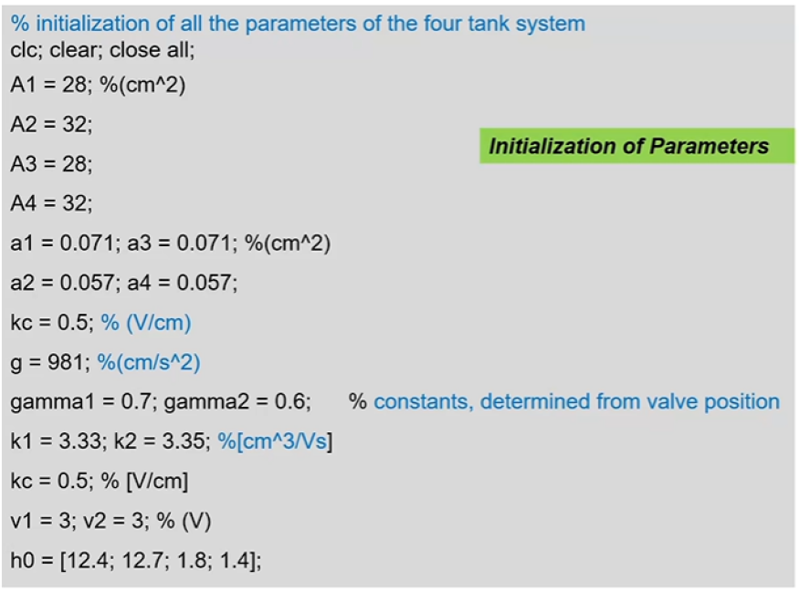

**MatLab Code:**

**Part 1:**

% initialization of all the parameters of the four tank system

clc; clear; close all;

Al = 28;

A2 = 32;

A3 = 28;

A4 = 32;

a1 = 0.071; a3 = 0.071;

a2 = 0.057; a4 = 0.057;

kc = 0.5;

g = 981;

gamma1 = 0.7; gamma2 = 0.6;

k1 = 3.33; k2 = 3.35;

kc = 0.5;

v1 = 3; v2 = 3;

h0 = (12.4; 12.7; 1.8; 1.4];

**Part 2:**

% initialization of the states and covariances

x0 = h0;

x_post = x0;

C= [kc 0 0 0; 0 kc 0 0];

n = 4;

P0 = 10^5 * eye(4);

N = 500;

**Part 3:**

L = chol(P0):

x0 = (x0 * ones(1,N))’ * randn(N,n) * L;

% Initialization of the states

x1_post = x0(:,1);

x2_post = x0(:,2);

x3_post = x0(:,3);

x4_post = x0(:,4);

**Part 4:**

% Prediction equation

for i = 1:N

x1_pri(i) = -a1/A1*sqrt(2*g*x1_post(i)) + a3/A1*sqrt(2*g*x3_post(i)) + (gamma1*k1*v1)/A1 + w1(i);

x2_pri(i) = -a2/A2*sqrt(2*g*x2_post(i)) + a4/A2*sqrt(2*g*x4_post(i)) + (gamma2*k1*v2)/A2 + w2(i);

x3_pri(i) = -a3/A3*sqrt(2*g*x3_post(i)) + (1 - gamma2)*k2*v2/A3 + w3(i)

x4_pri(i) = -a4/A4*sqrt(2*g*x4_post(i)) + (1 – gamma1)*k1*v1/A4 + w4(i)

End

**Part 5:**

x_pri = abs(x_pri);

x1_pri = abs(x1_pri);

x2_pri = abs(x2_pri);

x3_pri = abs(x3_pri);

x4_pri = abs(x4_pri);

**Part 6:**

M = length(wt);

Q = cumsum(wt);

indx = zeros(1, N);

T = linspace(0,1-(1/N),N) + **rand/N;**

i = 1;j =1;

while(i<=N && j<=M)

while Q(j) < T(i)

j = j+1

end

indx (i) = j;

x1_post(i) = x1_pri(j);

x2_post(i) = x2_pri(j);

x3_post(i) = x3_pri(j);

x4_post(i) = x4_pri(j);

i + 1;

end

**Part 7:**

% Importance Weights (Likelihood Function)

z1 = 12.4;

z2 = 12.7;

z = [z1; z2J;

z_true = z * ones(1,N);

R = 10 * eye(2);

z_est =C*x_pri

v = z_true - z_est;

for i = 1:N

q(i) = exp(-0.5 * (v(;,i))’ * inv(R) * v(:,i)));

end

% Normalizing the weights

for i = 1:N

wt(i) = q(i)/sum(q);

end